IMD Major Project Concept Report

|  |  |
| --- | --- |
| Student name: | Jack Penton (B00662595) |
| Mentor name: | Jonathan Wallace |
| Concept title: | CSS Animation Previewer (Ani-View) |

Introduction

A website in browser that allows you to select pre-made CSS3 Animation sets and watch a live preview play out in real time, along with dispensing the code that make the animation so as the user can copy it for their own use.

The ability to also change certain specifics of the animation such as time-delay and rotation to allow more customizability for each user’s needs.

There is a lot in current websites that you can get a preview of the animation that will happen but in order to use that animation or customize it you have first got to download the source file and finally link it in your code in order to use it, whereas the idea addressed here allows you to detail your own animation from the one given and immediately take that code.

Aim

The aim is to deliver a fully functional web-based Animation Previewer that accomplishes the necessary criteria and more of what has been set out to complete along with being a viable asset to modern front-end developers / designers within todays industry.

Objectives

* Meeting project / module deadlines before they are due.
* 22 hours per week working and developing upon the project.
* Create a Gantt chart to help manage time.
* Create the product to be cross-platform for PC, Tablet and Mobile.
* Create a range of simple animations.
* Finish a prototype by December.
* Develop the platform to have high accessibility.
* Create a database to help store user logins.
* Make a style tile and wireframe for initial design concepts of page layout and theme.

Scope

The Animation Previewer **should** include the following features:

A user sign-up and login in order to meet the assignments deliverables, a range of animations to be available and inputted into the selection of animations to choose from, an intuitive interface that allows for ease of use and high accessibility in order to broaden the audience and meet global website accessibility guidelines, the ability to download the selected animation for future use, a real-time preview of the animation selected, code made available to immediately copy to your clipboard for each animation and lastly sliders (or another type of input) in order to allow user customizability to the animation.

Features that **should not** be included as part of this project are as follows:

User profiles and account details pages as they are not part of the design structure and would only interfere with the service trying to be provided, payment gates or form of payment of any kind as it would be against general ethics in the creating of something intended to be helpful to the users in today’s industry and lastly advertisements as they are everyone’s detested web element.

Risks

|  |  |  |  |
| --- | --- | --- | --- |
| Name of Risk | Impact on Project | Probability of Occurrence | Solution |
| Animation Preview in Real-Time | This is the core feature of the project and thus without it, would fail the module. | High | Since this is core functionality, it will be the first to be challenged once a webpage has been made and therefore will receive the most care and attention to detail, mitigating the likelihood of it being a proceeding problem. |
| Code Dispenser | Core feature to the final product of this project, with its intended use being quite integral to what is trying to be accomplished. It also depends on whether “Animation Preview in Real-Time” can be achieved. | High | Allotted sufficient amount of time to research the problem and has been placed alongside at about halfway with the first risk in the development process. |
| User Login and Signup | Needed to meet Major Project deliverables for the SQL Database. | Medium | Since previous knowledge on how to accomplish this has been acquired, implementation should not be a problem. |
| User Interface and Design | Large amount of time needed to wireframe and flesh out a design that is minimalistic and easy to use is quite high. | High | Design up and flesh out a webpage with the needed inputs and iterate constantly in little snippets throughout development in unison with the other risks to fully realize the best layout. |
| Code Snippet Download | An optional feature that allows for more flexibility and a more all-round experience. | Low | Tasked for near the end of the development process cycle, so if time is available it can be implemented. |
| Sliders to adjust Animation | If this feature is not made available, then the potential user base for the product is reduced. | High | Probably one of the most complex parts of the project but one that is surely doable if enough time is available for it. |
| Knowledge of the unknown | Current technicalities to be implemented into the project of which the knowledge has not yet been acquired. | High | Keep up attendance to lectures, research techniques and such independently. |

Resources

The following resources **will** be needed:

* Database with MySQL – to store user login and signup details.
* Server hosting – to upload the project to the webserver for functionalities to work such as MySQL.
* Text Editor – to develop and iterate the project as a whole.
* Browser – to test, preview and use the product.
* Web Development languages (HTML5, CSS3, JavaScript, JQuery and MySQL).
* Computer – with an internet connection, and sufficient hardware.

Plan

There are many methodologies to use that have been thoroughly tried and tested which offer a range of different ways to go about developing a project depending on team size, time needed and type.

**Waterfall Method**

This method is suited to small projects and is straightforward in the sense that when you have your requirements and research nicely mapped out, you can proceed on down the steps of the process, just like a waterfall, completing each section until you reach the testing and deployment phase.

At this point you’ve went through each section, completed it and moved on and any problems that may occur are only found during the test period which makes it difficult, timely and costly to go back and iterate on what you have already made.

This methodology does not suit the needs of the current development process and therefore will not be used.

**Prototyping Method**

If time is not an issue the this methodology would probably be the direction to take, as it does not require you to have all your requirements readily defined and allows for constant iteration with each prototype by using whatever requirements you may have, design a prototype, develop it, review it and finally enhance.

With every cycle it allows you to see the project become more and more fleshed out.

The downside to the method is that even though it is well rounded, it takes more time and is more suited to larger team sizes. For these reasons this method will not be used as time is of the essence.

**Modified Waterfall Method**

This is the chosen method as it is the most beneficial for the project in how it operates:

Requirements Analysis

Code

Test

Deploy

Design

The Modified Waterfall Methodology is one that has been tried and tested, allows great manageability to the project at hand if requirements and research have been thought out properly, easy to use and well suited to individual practices.

This allows for a straightforward guide that allows constant iteration within each cycle to go back and change or improve upon certain aspects to the project while laying out the development process of which also has the advantage of being suitable for small individual projects.

A Gantt chart of the Time-Schedule will be aiming to coincide with is documented below:

It outlines the weeks for nearly every aspect of the first semester including the projects estimated timetable of development for each stage of the Modified Waterfall Methodology with further detail into the individual and the Hard & Soft Deadlines of the modules deliverables.

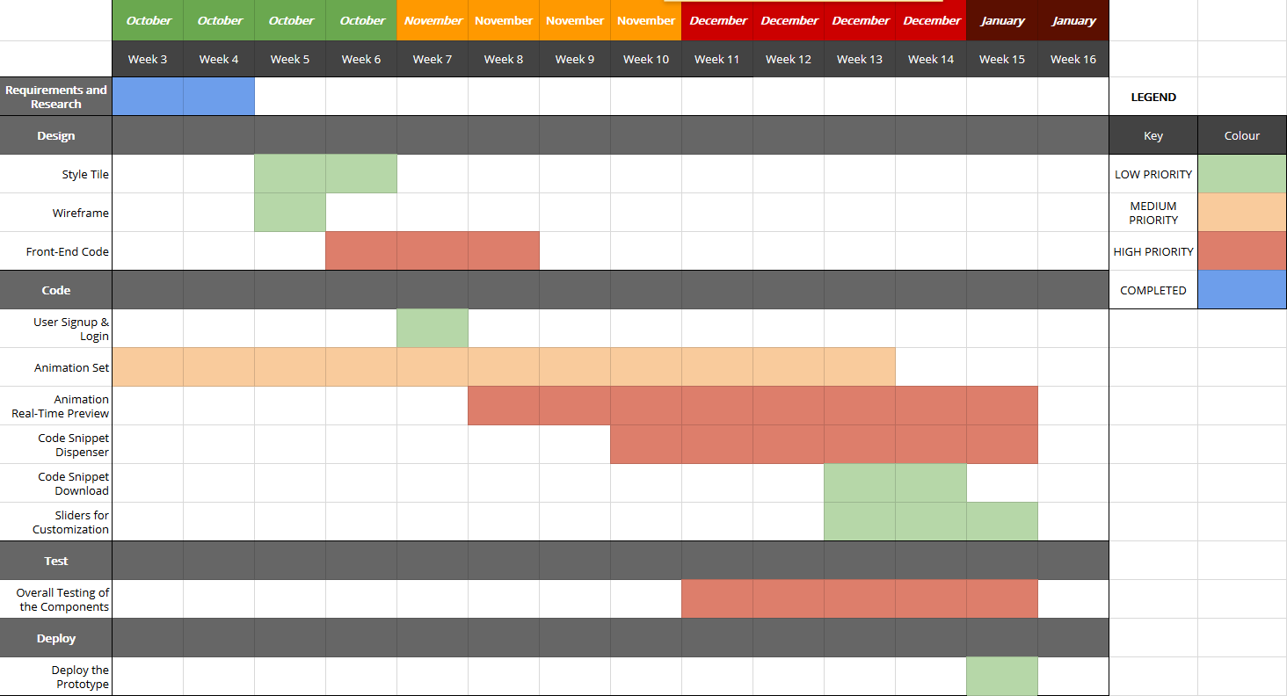

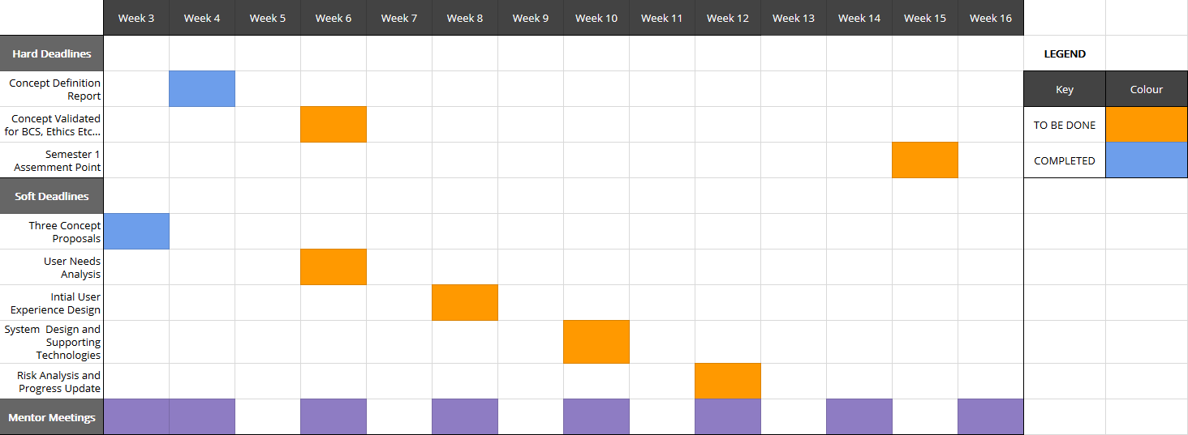

You can find the online version here:

https://docs.google.com/spreadsheets/d/1n8p2En7LdQRJOme7JWwX0zB9YSc9oVNN8GJP2v3LdWY/edit?usp=sharing

Background Research

Back in the early 2000’s animations and interactivity in websites were accomplished by using Adobe Flash Player which was widely used but has steadily declined ever since with more modern, optimized ways of getting the job done such as CSS3 Animations, Animated SVG’s, JavaScript, JQuery which has basically taken over the scene.

*“The post-Flash era is hardly free of animation. CSS animation is quickly becoming a cornerstone of user-friendly interfaces on mobile and desktop, and JavaScript libraries already exist to handle complex interactive animations.”*

* Rachel Nabors (Smashing Magazine)

In the World Wide Web the amount of progress happening on a constant basis is huge, with many new job titles being created in the process such as people specializing in Back-end, Front-end, Animation, Designer and UX Designers.

The part that will be focused on is the animation side of the web which has solidly ingrained itself within the industry that when used right, adds huge flair, creativity and can help distinguish you from the others.

*“Today animation became ingrained in web design and seems to be a great addition to many website elements.”*

* Julia Blake (Line 27)

So as animation with its uses and daily integrations growing every day, so have the number of open-source creative animation sets appearing on the web, usually accompanied by their own personalized homepage that lets you preview the sets they have to offer. Some examples of this would be Animate.css, Minimamente and ***Hover.css*** to only name a few, particularly with ***Animate.css*** and ***Minimamente*** of which are more in line with the direction of the idea presented in this report. You select / click on one of the animations and you will see it play out in real-time but that is it, no code to immediately use the animation you have selected, no download for only that snippet, you have to download the entire library in order to use it which in turn increases the overall file size of your website and therefore your website loading speed decreases.

Now sometimes it is ideal to have a whole stylesheet to work with at first, but the idea behind this project is to offer more flexibility to the whole fiasco of downloading the source, linking the stylesheet to your website, removing the unnecessary bloat from that stylesheet so on and so forth, whereas if the student can accomplish what he set out to do, designers & front-end developers can select an animation, specify its characteristics, copy that snippet of code into their clipboard and input it directly into the **one** stylesheet that they are already using.

The closest thing found that is along the same lines that this project is going for are things such as the box-shadow generator at ***cssmatic.com/box-shadow,*** it gives a preview of the result, sliders to customize the characteristics, and the code snippet output for you to directly use. It isn’t an animation previewer but it gives a good idea of the kind of traits being sought for to incorporate into the project.

References

Cssmatic.com. (2016). *Box Shadow CSS Generator | CSSmatic*. [Online] Available at: http://www.cssmatic.com/box-shadow [Accessed 11 Oct. 2016].

Minimamente.com. (2016). *Magic Animations CSS3*. [Online] Available at: https://www.minimamente.com/example/magic_animations [Accessed 11 Oct. 2016].

Hover.css. (2016). *Hover.css - A collection of CSS3 powered hover effects*. [Online] Available at: http://ianlunn.github.io/Hover/ [Accessed 12 Oct. 2016].

Daneden.github.io. (2016). *Animate.css*. [Online] Available at: https://daneden.github.io/animate.css/ [Accessed 13 Oct. 2016].

Blake, J. (2016). *Animation in Web Design: Why and When to Use*. [Online] Line25.com. Available at: http://line25.com/articles/animation-web-design-why-and-when-to-use [Accessed 12 Oct. 2016].

Nabors, R. and Nabors, R. (2014). *The State of Animation 2014 – Smashing Magazine*. [Online] Smashing Magazine. Available at: https://www.smashingmagazine.com/2014/11/the-state-of-animation-2014/ [Accessed 12 Oct. 2016].